- Create a project Folder
- Pip install virtualenv
- Virtualenv venv
- Cd venv
- Cd Scripts
- Activate (activate.bat file starts)
- Cd ..
- Cd ..
- Pip install django
- django-admin startproject mysite
- cd mysite
- python manage.py runserver

Sending Request to the Django Server = >
Via localhost web-browser (127.0.0.1:8000)

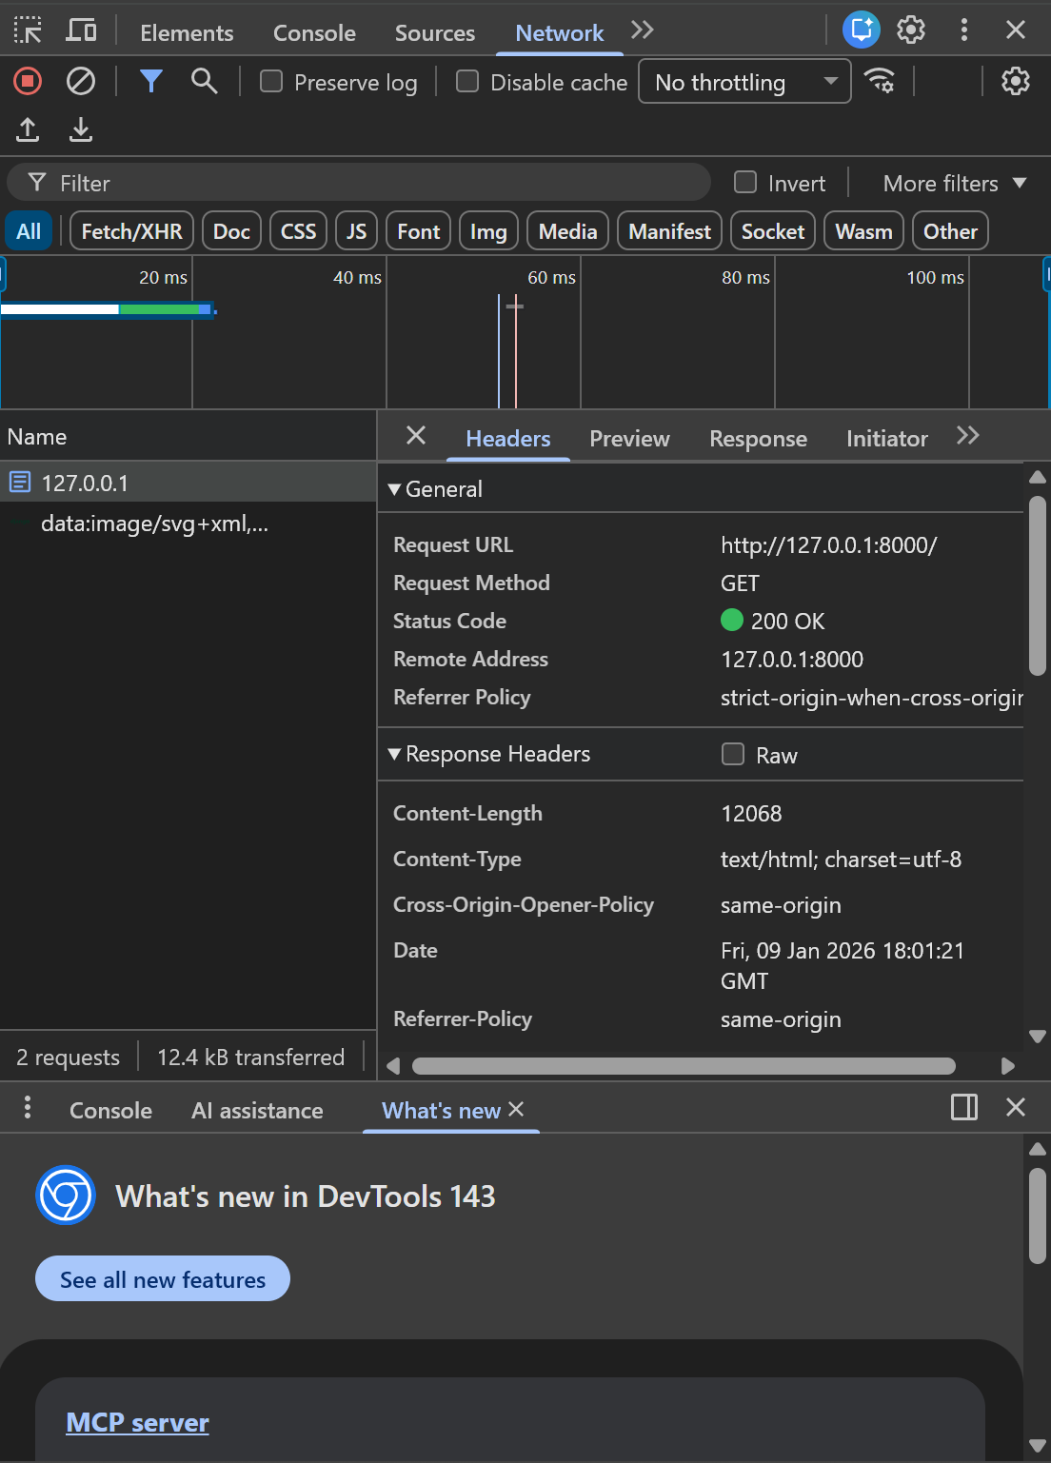
Response
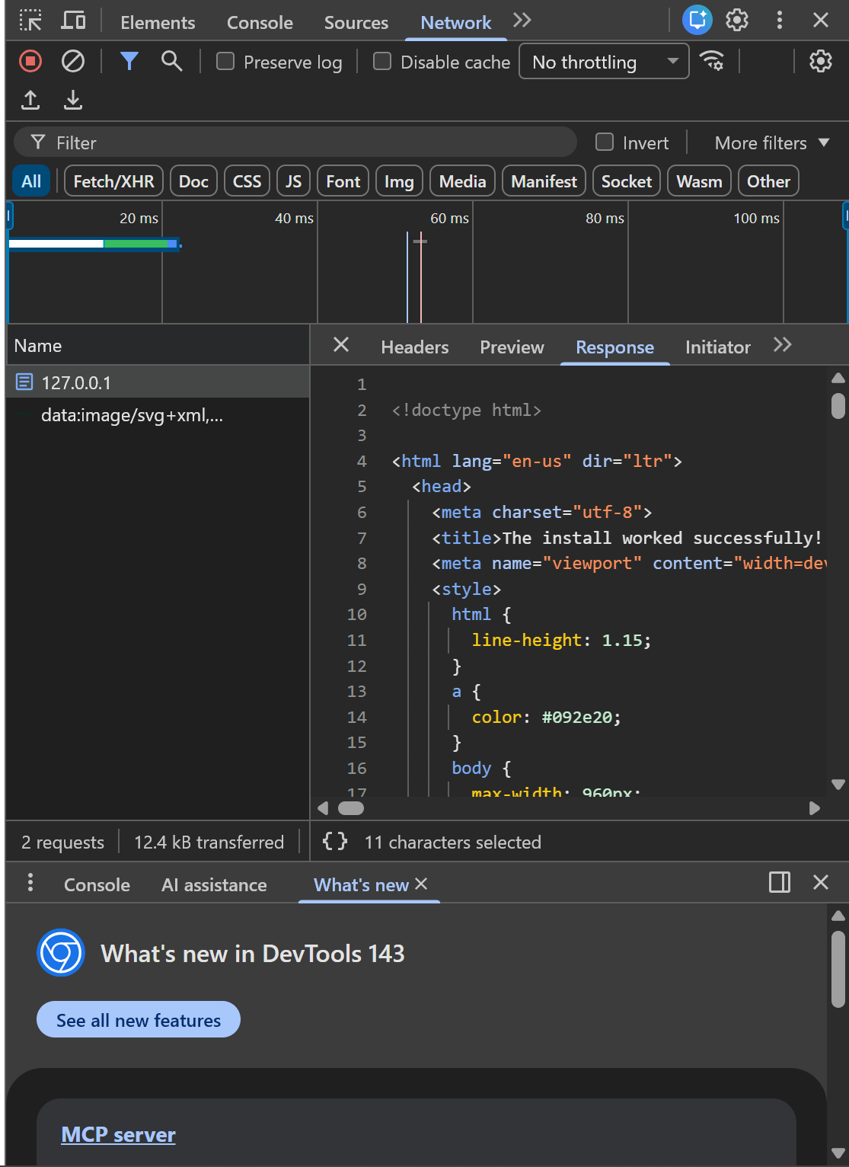

Create app
python manage.py startapp myapp
the myapp folder has a file named views.py
what are views in Django ?
views accept the http response from the user, analyse the request and send the appropriate http response to the user / client / web browser.
We need to connect the views to URL Patterns via the urls.py file.

